CALM Knowledge TransfeCitiusCloud IPAM Solution for Calm Implementation

Raaj Muthalaghu AV | Nutanix Services | Senior Consultant

Roshan Shetty | Nutanix Services | Senior Architect

Copyright 2017 CitiusCloud LLP.

Mumbai,

India

All rights reserved. This product is protected by INR and international copyright and intellectual property laws.

CitiusCloud is a trademark of CitiusCloud LLP in the India and/or other jurisdictions. All other marks and names mentioned herein may be trademarks of their respective companies.

Contents

Executive Summary 4

Forms 4

Login Form 4

Network Form 4

IPAddress Form 5

User Form 6

Report 7

Postgres Tables 7

User Table 7

Network Table 7

IPAddress Table 8

Expectation 8

# Executive Summary

This document describes the requirements for customized IPAM solution should follow to develop Web App that will logon user, create networks and allows to update hostname manually. The free IP request will do Rest Api call to get next available free IP from the network.

# Forms

There are 4 forms used in this Web App are login, network, User and IpAddress.

## Login Form

This tool is designed to login only by local users. Local User(for eg. Admin/Roshan/Raaj/RamaKant). Local user credential ,maintained in database table.

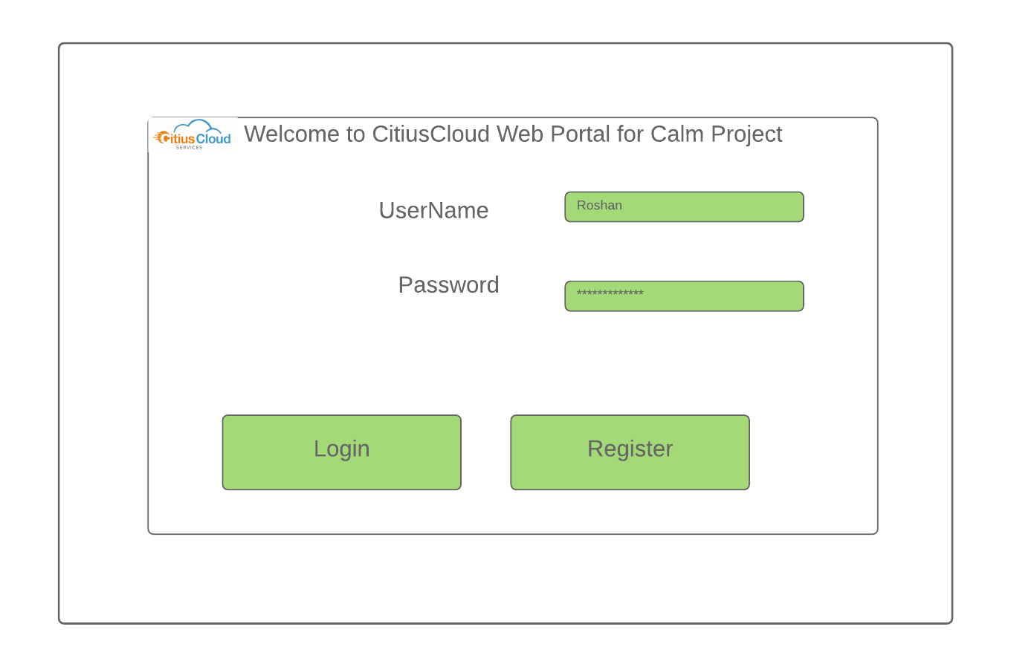

Note: Kindly use crypting package for password.

## Network Form

On successful login, we landed into Network/Subnet Registration form. The top panel contains network list. The bottom panel shows details of selected network.

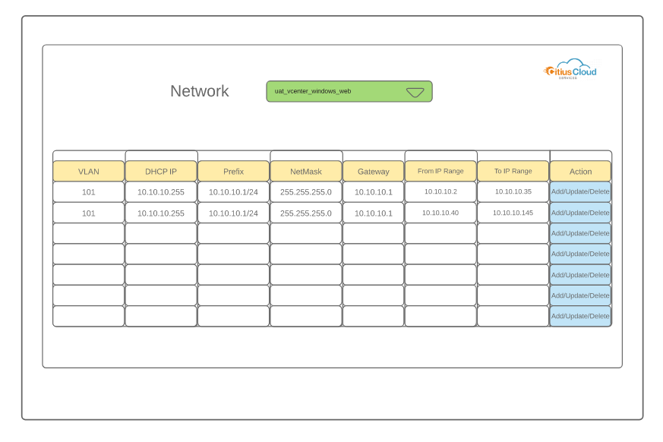

Multiple ranges of ipaddress can be added for a network. Each record contains vlanID, prefix, dhcp server ip, netmask, gateway, from and to ranges.

## IPAddress Form

This is grid form with manual update Hostname future. This form lists all ipaddresses for all the networks and its ranges. There is search box for filter the network and ipaddress status = All/Free/Assigned/Blocked.

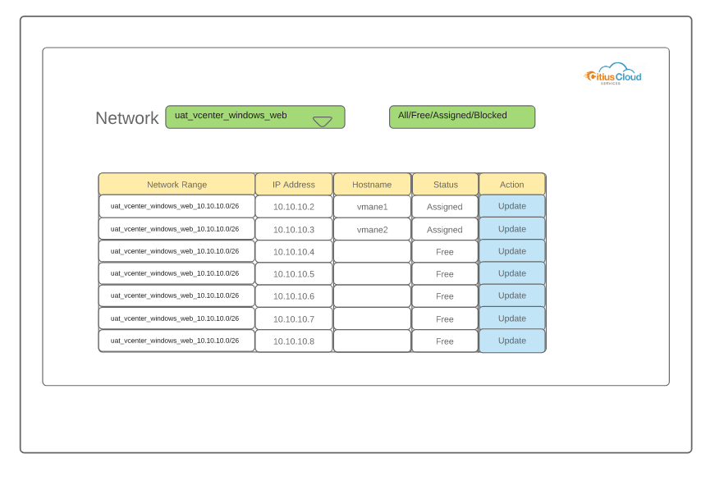

## User Form

This form is to create/update/delete local user.

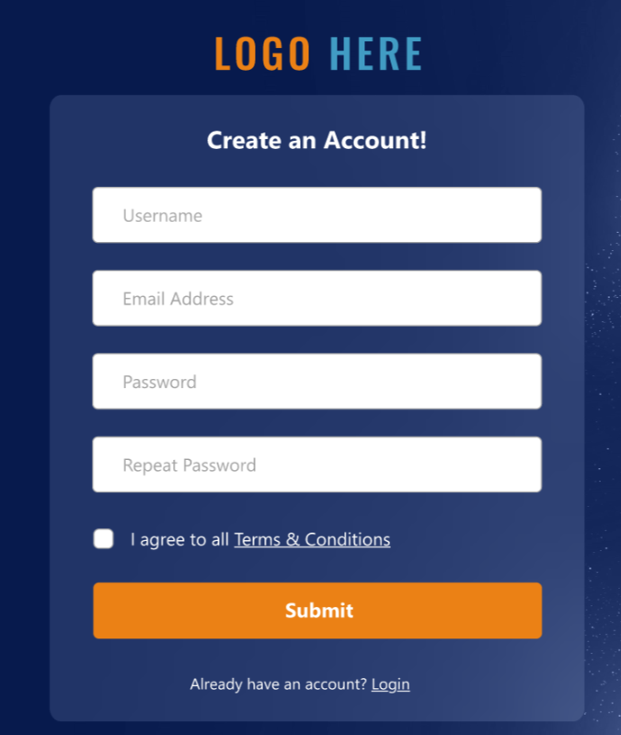

# Report

-----No reports

# Postgres Tables

## ipamUser Table

|  |  |
| --- | --- |
| UserName | Varchar(30) |
| Password | Varchar(100) |
| Admintype | Boolean |

## ipamNetwork Table

|  |  |  |
| --- | --- | --- |
| Network | Varchar(30) | (eg)Uat_vcenter_windows_web |
| Vlan | Numberic |  |
| Prefix | Varchar(30) | Eg.10.10.10.1/24 |
| Netmask | Varchar(30) |  |
| Gateway | Varchar(30) |  |
| FromIP | Varchar(30) |  |
| ToIP | Varchar(30) |  |

## ipamIP Table

|  |  |
| --- | --- |
| Network | Varchar(30) |
| Ip | Varchar(30) |
| Exclude | Boolean |
| Hostname | Varchar(30) |

# Expectation

1. Document detail the step by step of Setup, install development softwares, packages in customer environment and detail steps for build/deployment.
2. Code has to be uploaded into Github frequently.
3. On every form completion will do code walk through, unit test and will commit into Github.